GEN AI ISQTB Certification:

GenAI Foundation:

AI Spectrum:
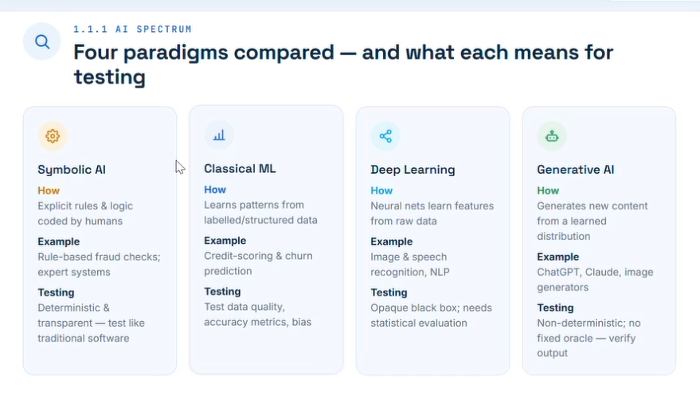
1. Symbolic AI
Symbolic AI is based on explicit rules and logic created by humans. The system follows predefined instructions, making behavior predictable and transparent.
Examples: Expert systems, rule-based fraud detection.
Testing Implications:
- Similar to traditional software testing.
- Inputs and outputs are deterministic.
- Testers can create clear test cases with expected results.
- Focus on validating business rules, logic flows, and edge cases.
2. Classical Machine Learning
Classical ML learns patterns from structured and labeled data instead of relying solely on handcrafted rules.
Examples: Credit scoring, churn prediction.
Testing Implications:
- Testing shifts toward assessing data quality and model performance.
- Key metrics include accuracy, precision, recall, and bias evaluation.
- Testers validate datasets, feature engineering, and prediction quality.
- Results are probabilistic rather than fully deterministic.
3. Deep Learning
Deep Learning uses multi-layer neural networks that automatically learn complex features from large volumes of data.
Examples: Image recognition, speech recognition, Natural Language Processing.
Testing Implications:
- Models behave like a "black box," making internal decisions difficult to interpret.
- Testing relies heavily on statistical evaluation and performance metrics.
- Focus areas include robustness, fairness, explainability, and model drift.
- Traditional code coverage provides limited insight into model quality.
4. Generative AI
Generative AI creates new content such as text, images, audio, and code using learned patterns from training data.
Examples: ChatGPT, Claude, image generation systems.
Testing Implications:
- Outputs are non-deterministic, meaning the same prompt may produce different responses.
- There is often no single "correct" answer or fixed oracle.
- Testing focuses on:
  - Groundedness and factuality
  - Safety and harmful content prevention
  - Prompt robustness
  - Response quality and relevance
  - Hallucination detection
  - Compliance with business requirements
Key Takeaway
As AI evolves from rule-based systems → machine learning → deep learning → generative AI, testing moves from deterministic verification of logic to statistical evaluation of behavior, quality, safety, and trustworthiness. The less deterministic the system becomes, the more important evaluation frameworks, monitoring, and risk-based testing approaches become.
One-line summary:
Traditional software is tested against expected outputs; Generative AI is evaluated against quality, safety, and business outcomes.

How an LLM Turns Your Prompt into an Answer
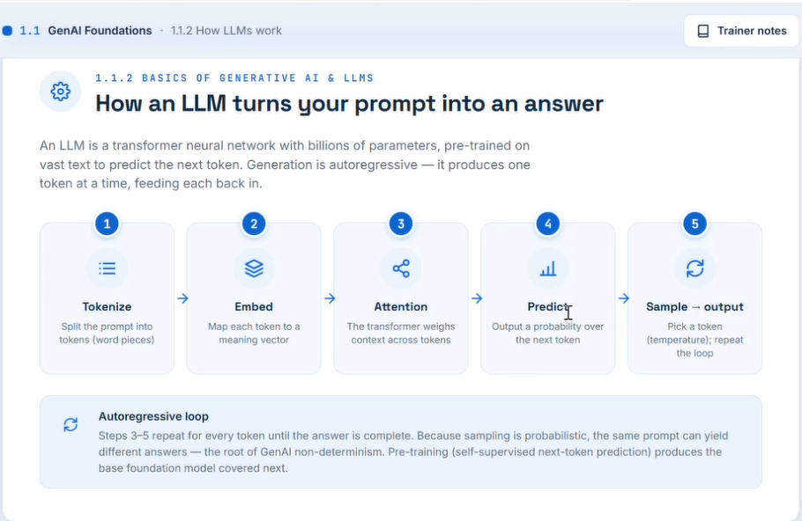
What is an LLM?
- An LLM (Large Language Model) is a type of transformer neural network trained on massive amounts of text.
- It learns to predict the next token (word or word piece) in a sequence.
- Text generation is autoregressive, meaning the model generates one token at a time and uses it as input for the next prediction.

1. Tokenization
Purpose: Break the prompt into smaller units called tokens.
Example:
"How are you?"
May become:
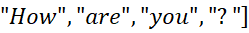
Key Point: LLMs work with tokens, not entire sentences.

2. Embedding
Purpose: Convert each token into a numerical representation called an embedding vector.
- Embeddings capture semantic meaning.
- Similar words have similar vector representations.
Example:
- "King" and "Queen" have related embeddings.
- "Car" and "Vehicle" are close in vector space.
Key Point: Tokens become numbers that the model can process.

3. Attention
Purpose: Understand relationships between tokens and determine which parts of the context are important.
Example:
"The cat chased the mouse because it was fast."
Attention helps determine what "it" refers to.
Key Point: Attention enables the model to consider the entire context when generating responses.

4. Prediction
Purpose: Calculate probabilities for possible next tokens.
Example: Prompt:
"The capital of France is"
Model probabilities:
- Paris → 95%
- Lyon → 3%
- Marseille → 2%
Key Point: The model predicts likelihoods, not fixed answers.

5. Sampling → Output
Purpose: Select the next token based on predicted probabilities.
Factors influencing selection:
- Temperature (controls randomness)
  - Low temperature → more deterministic
  - High temperature → more creative/random
Example:
"The capital of France is" → "Paris"
Key Point: Sampling determines the final generated text.

Autoregressive Loop
Steps 3 → 5 repeat continuously:
- Predict next token
- Select token
- Add token to output
- Feed it back into the model
- Repeat until completion
Example:
Prompt:
"AI is"
Generation:
"AI is" → "a" → "technology" → "that" → "helps" → "people" ...

Important Concepts
Transformer Architecture
- Uses self-attention to understand context.
- Forms the foundation of modern LLMs.
Next-Token Prediction
- Core training objective of LLMs.
- The model learns by predicting missing or future tokens.
Non-Determinism
- Same prompt can produce different outputs.
- Caused by probabilistic sampling and temperature settings.
Pre-Training
- Self-supervised learning on large text datasets.
- Creates the foundational knowledge of the model.

Quick Exam Summary
Prompt → Tokenize → Embed → Attention → Predict → Sample → Repeat until complete
Remember:
- Tokenize: Split text.
- Embed: Convert tokens to vectors.
- Attention: Understand context.
- Predict: Estimate next-token probabilities.
- Sample: Choose next token and generate output.
- Autoregressive Loop: Repeat until response is finished.

Vocabulary Every Tester Must Know (Generative AI & LLMs)
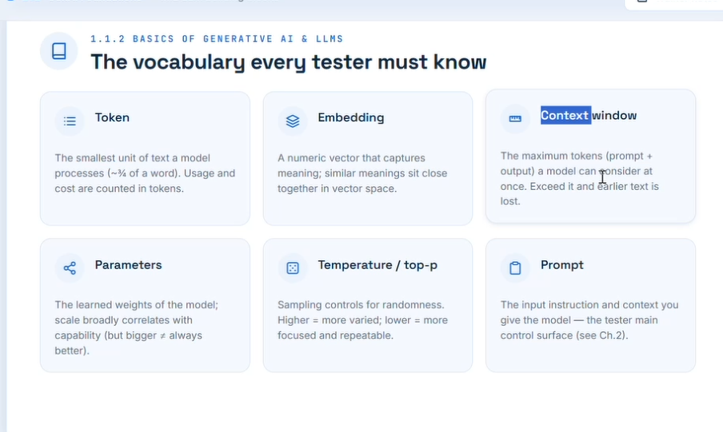
1. Token
Definition: Smallest unit of text processed by an LLM (approximately ¾ of a word on average).
Key Points:
- Input and output are measured in tokens.
- Model usage and cost are typically based on token count.
- Example:
  - "Hello world" → 2 to 3 tokens depending on tokenization.
Why testers should care:
- Large prompts consume more tokens.
- Token limits can affect test results and model behavior.

2. Embedding
Definition: A numeric vector representation of text that captures semantic meaning.
Key Points:
- Similar meanings are placed close together in vector space.
- Used for semantic search, recommendations, and Retrieval-Augmented Generation (RAG).
Example:
- "Car" and "Automobile" will have similar embeddings.
Why testers should care:
- Validate search relevance and retrieval accuracy.
- Test whether similar queries return similar results.

3. Context Window
Definition: Maximum number of tokens a model can process at one time (prompt + response).
Key Points:
- Includes system prompt, user prompt, conversation history, and generated output.
- When the limit is exceeded, older information may be dropped.
Why testers should care:
- Long conversations may lose earlier context.
- Test behavior near context-window limits.

4. Parameters
Definition: Learned weights inside the model that store knowledge and patterns.
Key Points:
- More parameters generally indicate greater capability, but not always.
- Parameters are determined during training.
Why testers should care:
- Different model sizes may produce different quality results.
- Larger models often demonstrate better reasoning and language understanding.

5. Temperature / Top-p
Temperature
Controls randomness in generated responses.
Temperature | Behavior
Low (0-0.3) | Predictable, deterministic
Medium (0.5-0.7) | Balanced
High (0.8-1+) | Creative, varied
Top-p (Nucleus Sampling)
Controls the pool of candidate tokens considered during generation.
Why testers should care:
- High values increase output variation.
- Useful for testing consistency and repeatability.

6. Prompt
Definition: Instructions and context provided to the model.
Key Points:
- Primary control mechanism for LLM behavior.
- Better prompts generally produce better results.
Components of a good prompt:
- Role
- Task
- Context
- Constraints
- Expected output format
Example:
Act as a software tester. Generate 10 edge-case test scenarios for a login page and return them in a table.
Why testers should care:
- Prompt quality directly impacts output quality.
- Prompt engineering is a critical testing skill for AI applications.

Quick Interview Summary
Term | One-Line Definition
Token | Smallest text unit processed by an LLM
Embedding | Numeric representation of meaning
Context Window | Maximum tokens the model can consider at once
Parameters | Learned weights of the model
Temperature | Controls randomness
Top-p | Controls token selection pool
Prompt | Instructions given to the model
Tester Takeaway
When testing GenAI applications, focus on:
- Prompt quality
- Token usage
- Context retention
- Consistency across Temperature/Top-p settings
- Retrieval accuracy (Embeddings)
- Behavior near Context Window limits
These six terms form the foundation of LLM and Generative AI testing.

Three Model Types – Know Which to Reach For
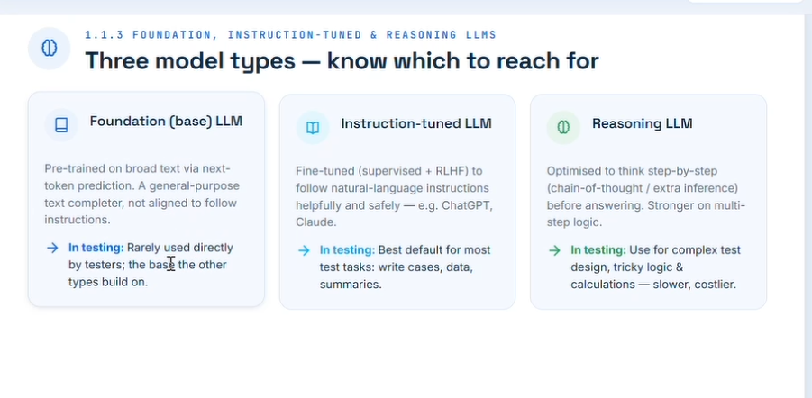
1. Foundation (Base) LLM
Definition
A pre-trained language model trained on massive amounts of text using next-token prediction. It learns language patterns but is not specifically trained to follow user instructions.
Key Characteristics
- General-purpose text completion model
- Predicts the most likely next word/token
- Not optimized for conversations or instructions
- Forms the foundation for other model types
Examples
- Base GPT models before instruction tuning
- Base Llama models
- Base Mistral models
In Testing
✅ Useful for understanding core model behavior
❌ Rarely used directly by testers or end users
Remember
Foundation LLM = Raw model with language knowledge but limited instruction-following ability.

2. Instruction-Tuned LLM
Definition
A foundation model that has been further trained to follow human instructions using techniques such as:
- Supervised Fine-Tuning (SFT)
- Reinforcement Learning from Human Feedback (RLHF)
Key Characteristics
- Understands requests and tasks
- Safer and more aligned with user intent
- Produces structured responses
- Better conversational abilities
Examples
- ChatGPT
- Claude
- Microsoft Copilot
- Gemini
In Testing
✅ Best default choice for most testing activities:
- Test case generation
- Test data creation
- Requirement summarization
- Bug report drafting
- Documentation reviews
Example Prompt
Generate 20 boundary value test cases for a registration form.
Remember
Instruction-Tuned LLM = Foundation model trained to reliably follow instructions.

3. Reasoning LLM
Definition
A specialized model optimized for multi-step reasoning before producing an answer.
Key Characteristics
- Breaks complex problems into smaller steps
- Better logical reasoning
- Stronger mathematical capabilities
- Improved decision-making and planning
Examples
- Advanced reasoning-focused GPT models
- Deep-reasoning AI agents
- Specialized reasoning models
In Testing
✅ Best for:
- Complex test design
- Decision trees
- Root cause analysis
- Risk analysis
- Multi-step calculations
- Workflow validation
Example Prompt
Analyze this payment workflow and identify all failure points and edge cases.
Trade-Offs
Advantage | Disadvantage
Better reasoning | Slower
More accurate logic | Higher cost
Better for complex tasks | More compute-intensive
Remember
Reasoning LLM = Thinks through the problem before answering.

Quick Comparison
Feature | Foundation LLM | Instruction-Tuned LLM | Reasoning LLM
Language Understanding | ✅ | ✅ | ✅
Follows Instructions | ❌ Limited | ✅ Excellent | ✅ Excellent
Conversational | ❌ | ✅ | ✅
Complex Logic | ⚠️ Moderate | ✅ Good | ✅ Excellent
Test Case Generation | ⚠️ | ✅ Best Default | ✅ For Complex Cases
Cost | Low | Medium | Highest
Speed | Fast | Fast | Slower

When Should a Tester Use Each?
Use Foundation LLM when:
- Researching model behavior
- Evaluating raw language capability
- Comparing model performance
Use Instruction-Tuned LLM when:
- Creating test cases
- Generating test data
- Writing bug reports
- Summarizing requirements
- Everyday testing tasks
Use Reasoning LLM when:
- Designing complex test strategies
- Performing root cause analysis
- Analyzing business rules
- Testing workflows with many decision branches
- Solving logic-heavy validation scenarios

Interview Question Answer
Q: What is the difference between Foundation, Instruction-Tuned, and Reasoning LLMs?
Answer:
- Foundation LLMs are raw pre-trained models that learn language patterns through next-token prediction.
- Instruction-Tuned LLMs are foundation models further trained to follow user instructions and are the best choice for most day-to-day tasks.
- Reasoning LLMs are optimized for multi-step thinking, logical reasoning, and solving complex problems before generating a response.

